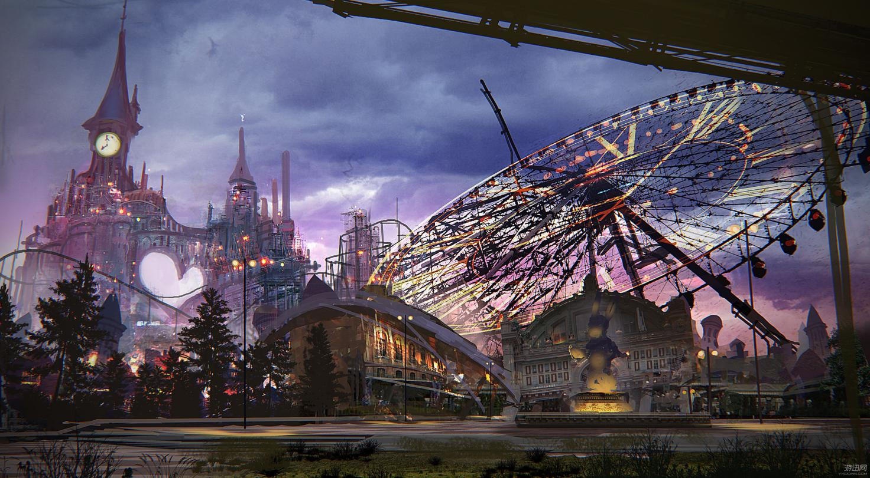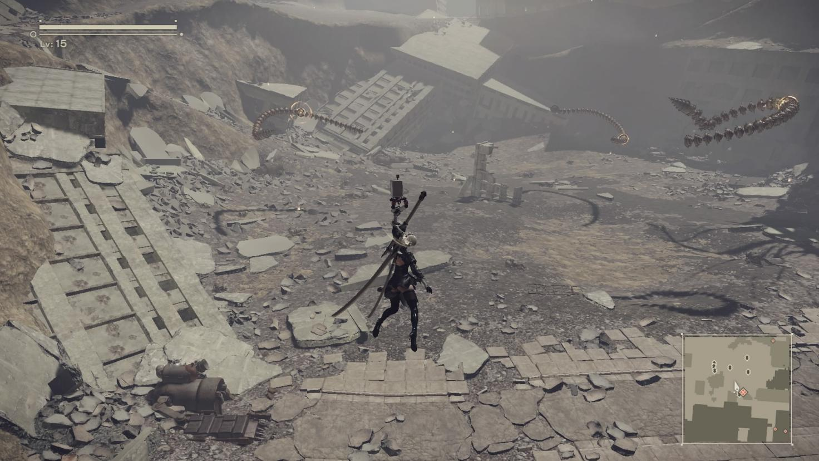The game I would like to talk about is Nier:Automata.

# NieR: Automata OST - Main Theme (The Weight of the World) :

<https://www.youtube.com/watch?v=4WUlvWPol_k>

# NieR: Automata OST - Preview Music (Vocal Song) :

https://www.youtube.com/watch?v=ksq89nUhyTE&list=PL-TSN1JqlGvo-f_jpcIqQzV8pJ0rXflYX

I pretty much like(may be my favorite) the general tune of this game – waste soil and cyberpunk with the overflowing smell of steam coming through the scene which for several times, reminds me of the distinctive style of Hayao Miyazaki, especially like the one of “Castle in the Sky”. For instance, the ferris wheel, such a complicate element for 3D modeling and level designing, is exquisitely placed ahead of the blank skyline of an amusement park. Since the path in front of the amusement park is a part of a daily request, players would repeatedly pass through the ferris wheel and get shocked every time for its heart-quaking atmosphere. **This is smart enough to consider not only how players would feel once seen the view but also how they would react after hundreds and thousands of encounters.** The same strategy is adopted in terms of music as well. Besides different melody, the game takes great advantage from applying variations of a same piece of music. Instead of feeling bored, quite the opposite, **music with the same theme may offer players high cognition of the story and indirectly provide them an influence gaming experience.** From one subtle design to another as what mentioned earlier, Nier:Automata controls precise balance between repetition and variation that definitely deserves the praise as an artwork.

I guess that how delicate the picture or music is just a shallow layer of a game while how they could activate certain emotion of players being the genuine purpose. Of course, all artistic consideration is based on an enough playable game. **Thus for a game designer, he should always spectate his game form three professional aspects: engineers’, artists’ and psychologists’.**